DESERIALIZATION:
Helpers/TestDataHelpr.cs (Education)
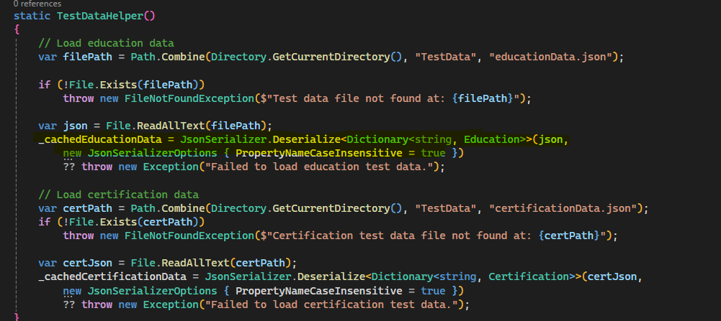
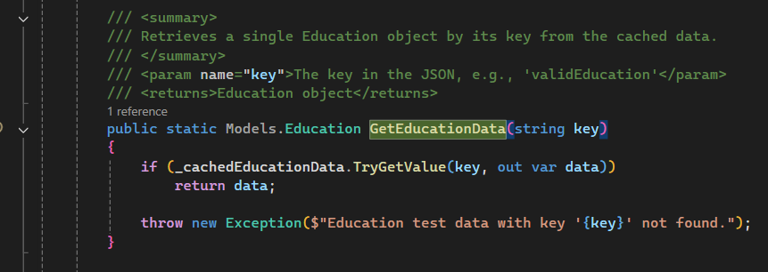
StepDefinition calls GetEducationData(dataKey) : sample dataKey is “validEducation”
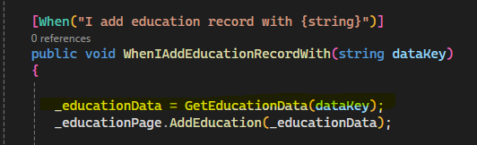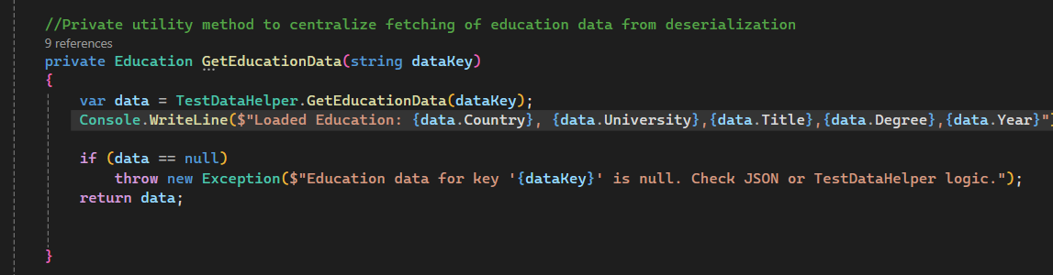

Education Test Output:
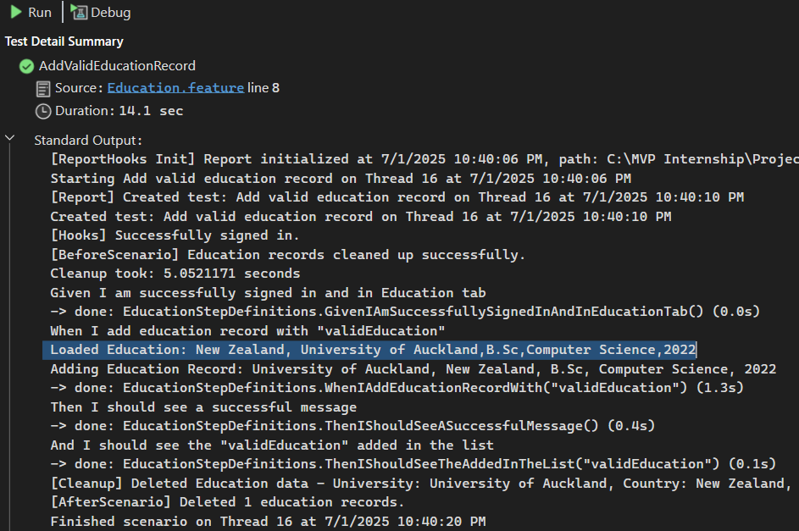

Helpers/TestDataHelpr.cs (Certification)
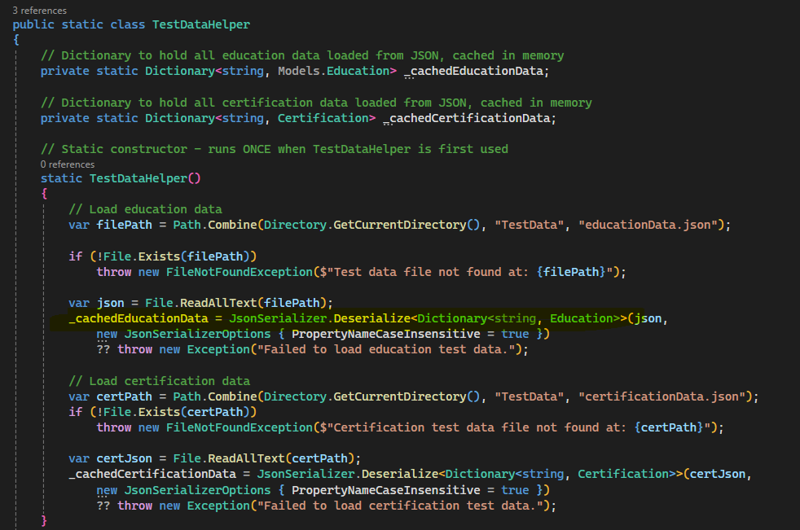
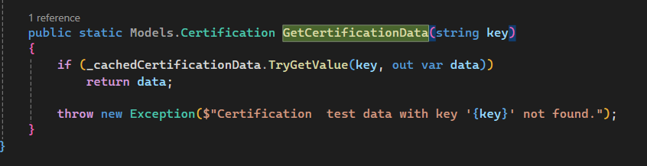
Sted Definition calls GetCertificationData(dataKey) : sample dataKey is “validCertification”
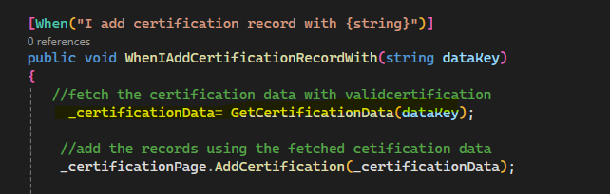
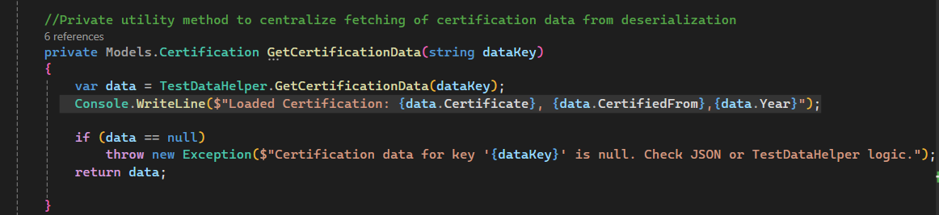
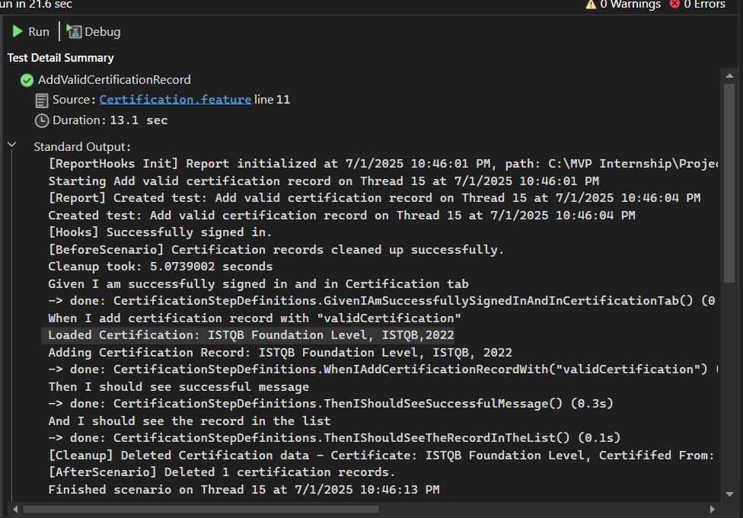
Education Json file:
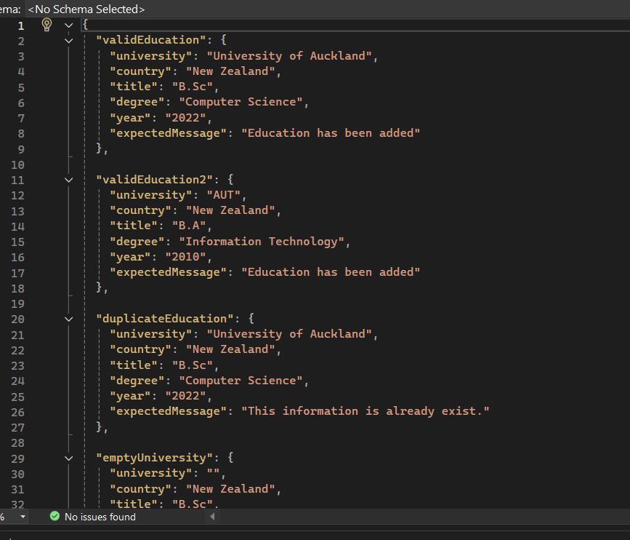
Education Model class:
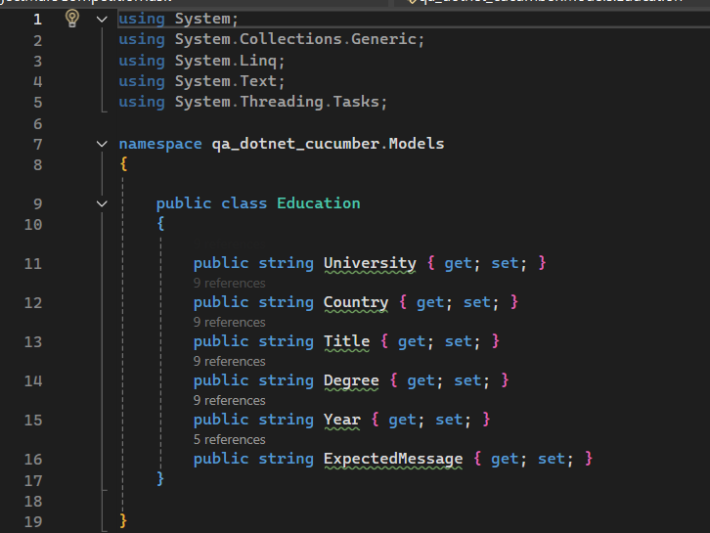

Certification Json file:
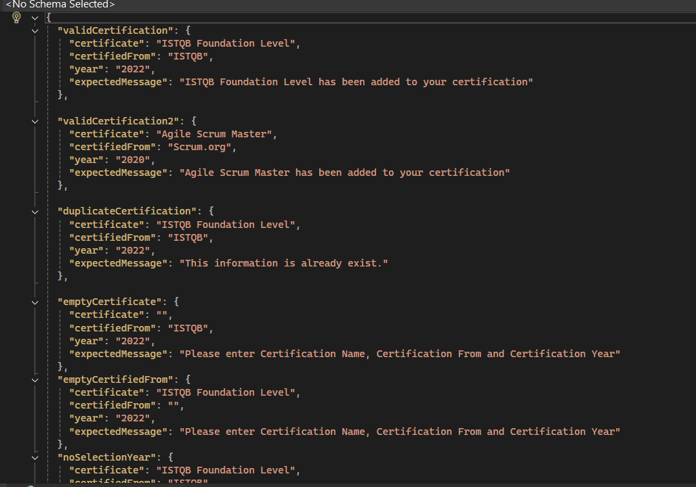
Certification Model class:
